**Md.Sabbir Ahmed**

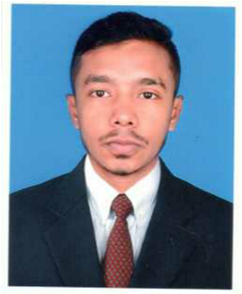

Malling Address-83/A, South Mugda 3rdLane

P.O-Bashaboo, P.S-Mugda, Dhaka-1214.

Mobile-01683240007,01930178948

E-mail:sabbir.aahmd@gmail.com

CAREER OBJECTIVE To work in a challenging and dynamic environment and to keep

adding value to the organization that I represent and serve ,while

also can currently upgrading my skills and knowledge.

WORKEXPERIENCE 

* Junior officer at Bkash.
* Team leader at Transcom Foods ltd.
* Team member at Secret Recipe Bangladesh.
* Sales exicutive at Creative Technologies**.**

EDUCATIONANDTRAINING 

* Bachelor of Science(BSc.)(5years)
  + - * University : Dhaka College, Dhaka.
      * Subject : Zoology.
      * Result : 2.80/4.00
      * Major In : Science.
* Higher Secondary Certificate Examination(2years)
  + - * College : Dhaka City College, Dhaka.
      * Result : 3.90/5.00
      * Year : 2013
      * Major In : Science.
* Secondary School Certificate Examination(10years)
  + - * School : Motijheel Model High School, Dhaka.
      * Result : 5.00/5.00
      * Year : 2011
      * Major In : Science.

PERSONALSKILLS 

|  |  |
| --- | --- |
| LANGUAGES  Communication skills  Job-related skills  Computer skills  Personal Strength  PERSONAL  INFORMATION | * Bangali, English( written,spoken,listen) * Good communication skills among sales,customer service and production. * Good command of resource appraisal and forecast in any production level. * Efficient at Microsoft Windows Platform. * Skilled in word processing software. * Efficiency in Internet Browsing and Email. * Well-organized and proficient with details. * Excellent intern personal and team skills. * Able to work under pressure and to make well reasoned.   Father’s Name : Din Mohammad  Mother’s Name : Mrs. Shakina  Gender : Male  Date of Birth : August 17, 1995  Nationality : Bangladeshi (ByBirth)  Religion : Islam (Sunnih)  Marital Status : Unmarried |

Present Address : 83/A South Mugda,Dhaka,Bangladesh

Permanent Address : 83/A South Mugda,Dhaka,Bangladesh.